RESUME
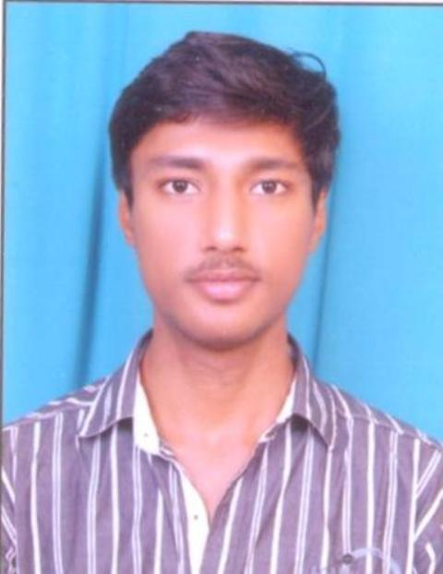

R.SAI SRIKANTH RAJ Mobile No :9985511350
Flat no201,401, Opposite Nch market Email Id: srikanth.raj18@gmail.com
Market lane,
Ameerpet,
Hyderabad,
TELANGANA(500016).
OBJECTIVE:
To be associated with a firm that gives me scope to learn and provide career
Development opportunities, giving my professional career a great start.
EDUCATIONAL QUALIFICATION:

COURSE | INSTITUTION | BOARD/UNIVERSITY | YEAR | AGGREGATE
B.Tech  (CSE) | Bandari Srinivas Institute of Technology | JNTUH | 2016 | 65.2%
Intermediate | NRI junior  College | IPE | 2012 | 57.6%
X standard | Gowtham model school | SSC | 2010 | 56.9%

TECHNICAL SKILLS:

Operating system : Windows XP, Windows 7, Windows 10
Software worked on : C PROGRAMMING , WEB TECHNOLOGY.

PROJECTS :

MINI PROJECT:
TITLE: PROJECT STATUS MANAGEMENT SYSTEM.

DESCRIPTION : Project status management system is used to reduce the time period of the data which a is to perform multipil task in an process.
MAJOR PROJECT:
TITLE: CAPTCHA AS A GRAPHICAL INTERFACE AS A CLICK BASED TECHNOLOGY

DESCRIPTION: Uses in securing the data in a form of CLICK BASED Technology

ACHIEVEMENTS:
- Organized and Co-ordinate different events in college technical fests.
- Won 1 prize in different cultural activities at school level.

EXTRA CURRICULAR ACTIVITIES:
- Playing Indoor and Outdoor games.
- Member of Contraption club of our college.

HOBBIES:
Reading books.
Painting
Creating blogs

PERSONAL PROFILE:
Name : R SAI SRIKANTH RAJ
Father’s Name : R RAJ KUMAR
Mother’s Name : R JYOTHIRMAI
D.O.B : 20 MARCH 1995
Gender : Male
Nationality : Indian
Languages known : Telugu , English , Hindi.

DECLARATION:
I here by declare that all the information mentioned above are true and correct to the best of my knowledge and belief.

Date: R.sai srikanth raj
Place: Hyderabad (Signature)

